Java Tutorial 1.4
Q1 | Write a Java program to store 10 integers in an array and print only the prime numbers from it.
Code | class PrimeInArray  {  public static void main(String[] args)  {  int[] arr = {12, 5, 7, 19, 24, 31, 40, 43, 50, 53};  for (int i = 0; i < arr.length; i++)  {  int c = 0;  for (int j = 1; j <= arr[i]; j++)  {  if (arr[i] % j == 0)  {  c++;  }  }  if (c == 2)  {  System.out.println(arr[i]);  }  }  }  }
Output | 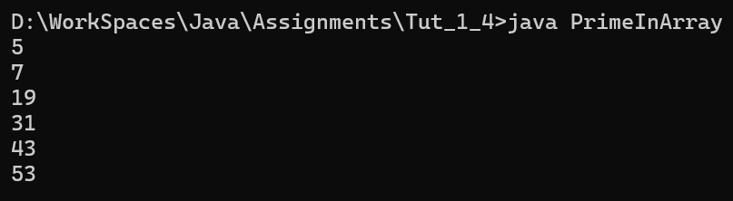
Q2 | Write a program to find the second largest and second smallest element in an array without using sorting.
Code | class SecondMinMax  {  public static void main(String[] args)  {  int[] arr = {15, 2, 8, 20, 5, 12};  int max = Integer.MIN_VALUE;  int secondMax = Integer.MIN_VALUE;  int min = Integer.MAX_VALUE;  int secondMin = Integer.MAX_VALUE;  for (int i = 0; i < arr.length; i++)  {  if (arr[i] > max)  {  secondMax = max;  max = arr[i];  }  else if (arr[i] > secondMax && arr[i] != max)  {  secondMax = arr[i];  }  if (arr[i] < min)  {  secondMin = min;  min = arr[i];  }  else if (arr[i] < secondMin && arr[i] != min)  {  secondMin = arr[i];  }  }  System.out.println("Second Largest: " + secondMax);  System.out.println("Second Smallest: " + secondMin);  }  }
Output | 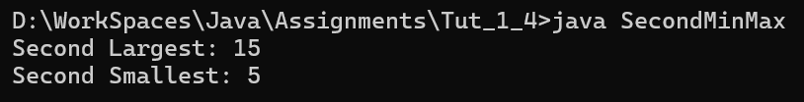
Q3 | Write a program to check whether an array is a palindrome array or not.
Code | class PalindromeArray  {  public static void main(String[] args)  {  int[] arr = {1, 2, 3, 2, 1};  boolean isPalindrome = true;  int n = arr.length;  for (int i = 0; i < n / 2; i++)  {  if (arr[i] != arr[n - 1 - i])  {  isPalindrome = false;  break;  }  }  if (isPalindrome)  {  System.out.println("Array is a palindrome");  }  else  {  System.out.println("Array is not a palindrome");  }  }  }
Output | 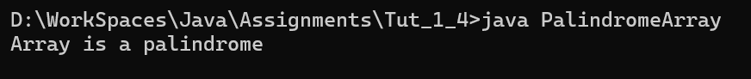
Q4 | Write a Java program to accept marks of N students (user input size) and display the highest, lowest, and average marks.
Code | import java.util.Scanner;  class StudentMarks  {  public static void main(String[] args)  {  Scanner sc = new Scanner(System.in);  System.out.print("Enter number of students: ");  int n = sc.nextInt();  int[] marks = new int[n];  int sum = 0;  int highest = Integer.MIN_VALUE;  int lowest = Integer.MAX_VALUE;  for (int i = 0; i < n; i++)  {  System.out.print("Enter marks for student " + (i + 1) + ": ");  marks[i] = sc.nextInt();  sum += marks[i];  if (marks[i] > highest)  {  highest = marks[i];  }  if (marks[i] < lowest)  {  lowest = marks[i];  }  }  double average = (double) sum / n;  System.out.println("Highest Marks: " + highest);  System.out.println("Lowest Marks: " + lowest);  System.out.println("Average Marks: " + average);  }  }
Output | 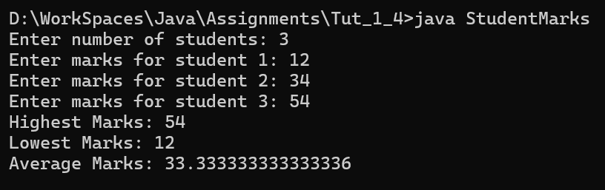
Q1 | Write a program to print the reverse multiplication table of a given number (from 10 to 1).
Code | import java.util.Scanner;  class ReverseTable  {  public static void main(String[] args)  {  Scanner sc = new Scanner(System.in);  System.out.print("Enter a number: ");  int num = sc.nextInt();  for (int i = 10; i >= 1; i--)  {  System.out.println(num + " x " + i + " = " + (num * i));  }  }  }
Output | 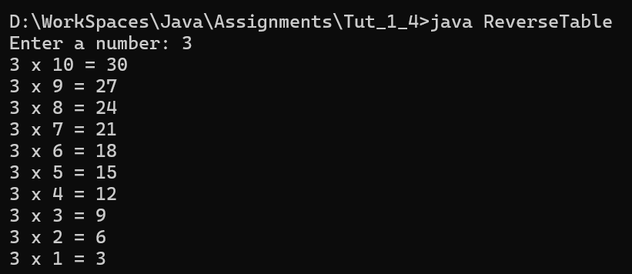
Q2 | Write a program to calculate the factorial of a number using recursion and loop (compare both).
Code | import java.util.Scanner;  class FactorialCompare  {  static int factRec(int n)  {  if (n == 0 || n == 1)  {  return 1;  }  return n * factRec(n - 1);  }  public static void main(String[] args)  {  Scanner sc = new Scanner(System.in);  System.out.print("Enter a number: ");  int n = sc.nextInt();  int factLoop = 1;  for (int i = 1; i <= n; i++)  {  factLoop *= i;  }  int factRecursive = factRec(n);  System.out.println("Factorial using Loop: " + factLoop);  System.out.println("Factorial using Recursion: " + factRecursive);  }  }
Output | 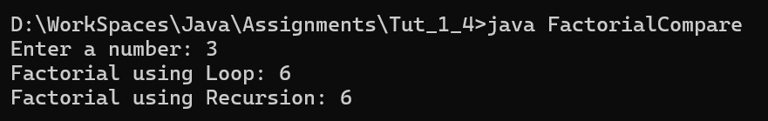
Q3 | Write a program to check whether a given number is palindrome using a loop.
Code | import java.util.Scanner;  class PalindromeNumber  {  public static void main(String[] args)  {  Scanner sc = new Scanner(System.in);  System.out.print("Enter a number: ");  int num = sc.nextInt();  int original = num;  int reverse = 0;  while (num != 0)  {  int digit = num % 10;  reverse = reverse * 10 + digit;  num /= 10;  }  if (original == reverse)  {  System.out.println("Palindrome number");  }  else  {  System.out.println("Not a palindrome number");  }  }  }
Output | 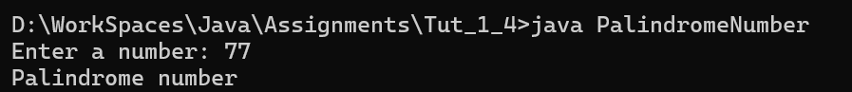
Q4 | Write a program to print a below pattern using nested loops.
Code | class PatternDisplay  {  public static void main(String[] args)  {  for (int i = 1; i <= 3; i++)  {  for (int j = 1; j <= 4 - i; j++)  {  System.out.print(" ");  }  for (int k = 1; k <= (2 * i - 1); k++)  {  System.out.print("*");  }  System.out.println();  }  for (int i = 1; i <= 7; i++)  {  System.out.print(i);  }  System.out.println();  for (int i = 3; i >= 1; i--)  {  for (int j = 1; j <= 4 - i; j++)  {  System.out.print(" ");  }  for (int k = 1; k <= (2 * i - 1); k++)  {  System.out.print("*");  }  System.out.println();  }  }  }
Output | 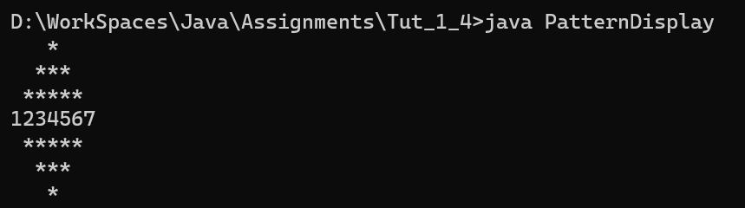
Q5 | Write a program to implement matrix addition and multiplication using 2D arrays.
Code | class MatrixOperations  {  public static void main(String[] args)  {  int[][] a = {{1, 2}, {3, 4}};  int[][] b = {{5, 6}, {7, 8}};  int[][] sum = new int[2][2];  int[][] prod = new int[2][2];  for (int i = 0; i < 2; i++)  {  for (int j = 0; j < 2; j++)  {  sum[i][j] = a[i][j] + b[i][j];  }  }  for (int i = 0; i < 2; i++)  {  for (int j = 0; j < 2; j++)  {  prod[i][j] = 0;  for (int k = 0; k < 2; k++)  {  prod[i][j] += a[i][k] * b[k][j];  }  }  }  System.out.println("Addition:");  for (int i = 0; i < 2; i++)  {  for (int j = 0; j < 2; j++)  {  System.out.print(sum[i][j] + " ");  }  System.out.println();  }  System.out.println("Multiplication:");  for (int i = 0; i < 2; i++)  {  for (int j = 0; j < 2; j++)  {  System.out.print(prod[i][j] + " ");  }  System.out.println();  }  }  }
Output | 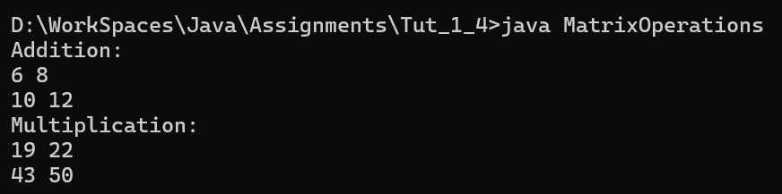
Q1 | Write a Java program to create a jagged array of 3 rows (2, 3, 4 elements). Fill values from the user and print the jagged array.
Code | import java.util.Scanner;  class JaggedArrayBasic  {  public static void main(String[] args)  {  Scanner sc = new Scanner(System.in);  int[][] arr = new int[3][];  arr[0] = new int[2];  arr[1] = new int[3];  arr[2] = new int[4];  for (int i = 0; i < arr.length; i++)  {  for (int j = 0; j < arr[i].length; j++)  {  System.out.print("Enter value for row " + i + " col " + j + ": ");  arr[i][j] = sc.nextInt();  }  }  System.out.println("Jagged Array Elements:");  for (int i = 0; i < arr.length; i++)  {  for (int j = 0; j < arr[i].length; j++)  {  System.out.print(arr[i][j] + " ");  }  System.out.println();  }  }  }
Output | 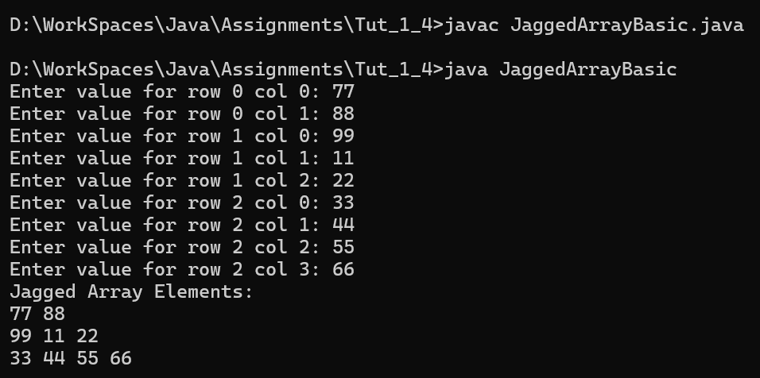
Q2 | Suppose 3 students appeared in different numbers of subjects. Use a jagged array to store marks and print each student’s marks.
Code | import java.util.Scanner;  class StudentMarksJagged  {  public static void main(String[] args)  {  Scanner sc = new Scanner(System.in);  int[][] marks = new int[3][];  marks[0] = new int[2];  marks[1] = new int[4];  marks[2] = new int[3];  String[] students = {"Hardik", "Krunal", "Kishan"};  for (int i = 0; i < marks.length; i++)  {  System.out.println("Enter marks for " + students[i] + ":");  for (int j = 0; j < marks[i].length; j++)  {  System.out.print("Subject " + (j + 1) + ": ");  marks[i][j] = sc.nextInt();  }  }  System.out.println();  for (int i = 0; i < marks.length; i++)  {  System.out.print(students[i] + "'s marks: ");  for (int j = 0; j < marks[i].length; j++)  {  System.out.print(marks[i][j] + " ");  }  System.out.println();  }  }  }
Output | 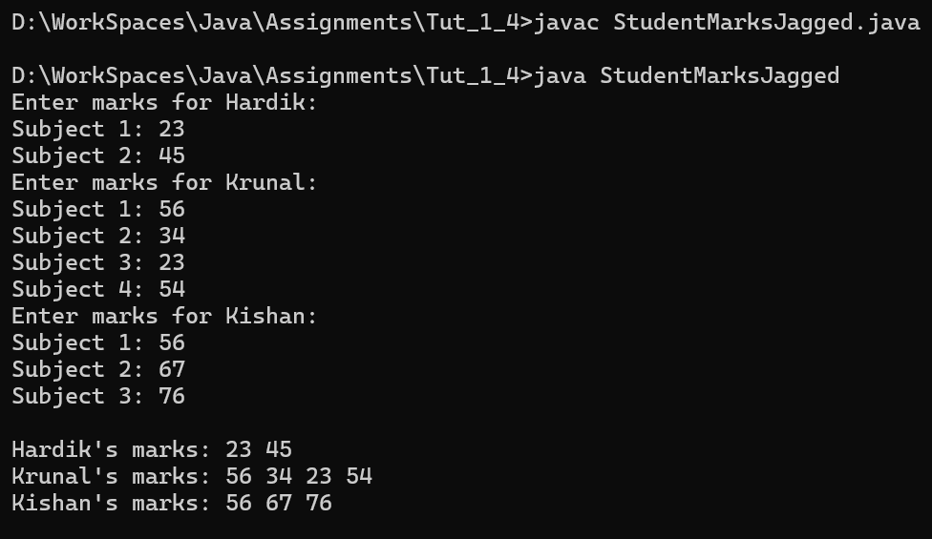
Q3 | Write a program to store elements in a jagged array and find the maximum element from the entire jagged array.
Code | class JaggedArrayMax  {  public static void main(String[] args)  {  int[][] arr = {  {12, 45},  {9, 88, 34},  {56, 99, 21, 10}  };  int max = arr[0][0];  for (int i = 0; i < arr.length; i++)  {  for (int j = 0; j < arr[i].length; j++)  {  if (arr[i][j] > max)  {  max = arr[i][j];  }  }  }  System.out.println("Maximum element in the jagged array: " + max);  }  }
Output | 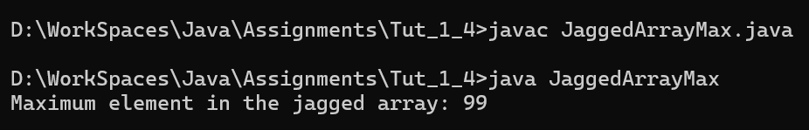
Q4 | Write a program to print a below pattern using jagged array.
Code | class JaggedArrayPattern  {  public static void main(String[] args)  {  int[][] arr = new int[4][];  for (int i = 0; i < 4; i++)  {  arr[i] = new int[i + 1];  for (int j = 0; j <= i; j++)  {  arr[i][j] = j + 1;  }  }  for (int i = 0; i < arr.length; i++)  {  for (int j = 0; j < arr[i].length; j++)  {  System.out.print(arr[i][j] + " ");  }  System.out.println();  }  }  }
Output | 